Class Rules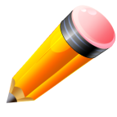
Our class rules are designed to keep children safe and to create a fair learning environment for all children. We will spend the first few days reviewing these rules and practicing them.
The rules for our classroom are:
- Treat others the way you want to be treated.
- Always try your best!
- Follow directions.
- Walk in classrooms and hallways.
- Raise hand to share ideas.
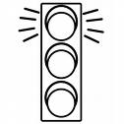Stoplight
We use a stoplight to track behavior. Everyday children will start on “green light” and their goal will be to stay on “green light” for the day. You will see a stoplight at the top of their homework sheet that will be filled out daily.
- If a child chooses to break a rule, they will receive a verbal reminder and will remain on “green light.”
- If a child chooses to break a rule again we will have a discussion about what choice they made and what they can do in the future to make a better choice. There will be a yellow light on their homework folder and an explanation.
- If your child chooses to break another rule we will have another discussion. There will be a red light on their homework folder and an explanation. If your child has difficulty following the classroom rules on a regular basis, you will be contacted.
Students that make good choices and stay on “green light” for the week will be rewarded with good work coupons.

